**SOFTWARE DEVELOPMENT LABORATORY**

**EXPIMENT 3:**

**PLAN THE SPRINT**

**AIM:**

To create and plan the sprint using Monday.com. The purpose of sprint planning is for the team to commit to complete a collection of stories that add new functionality to the product by the end of the sprint.

**PROCEDURE:**

In the Monday.com website sign up with email and password and create the project with the necessary details.

Open the release backlog by opening the respective project name.

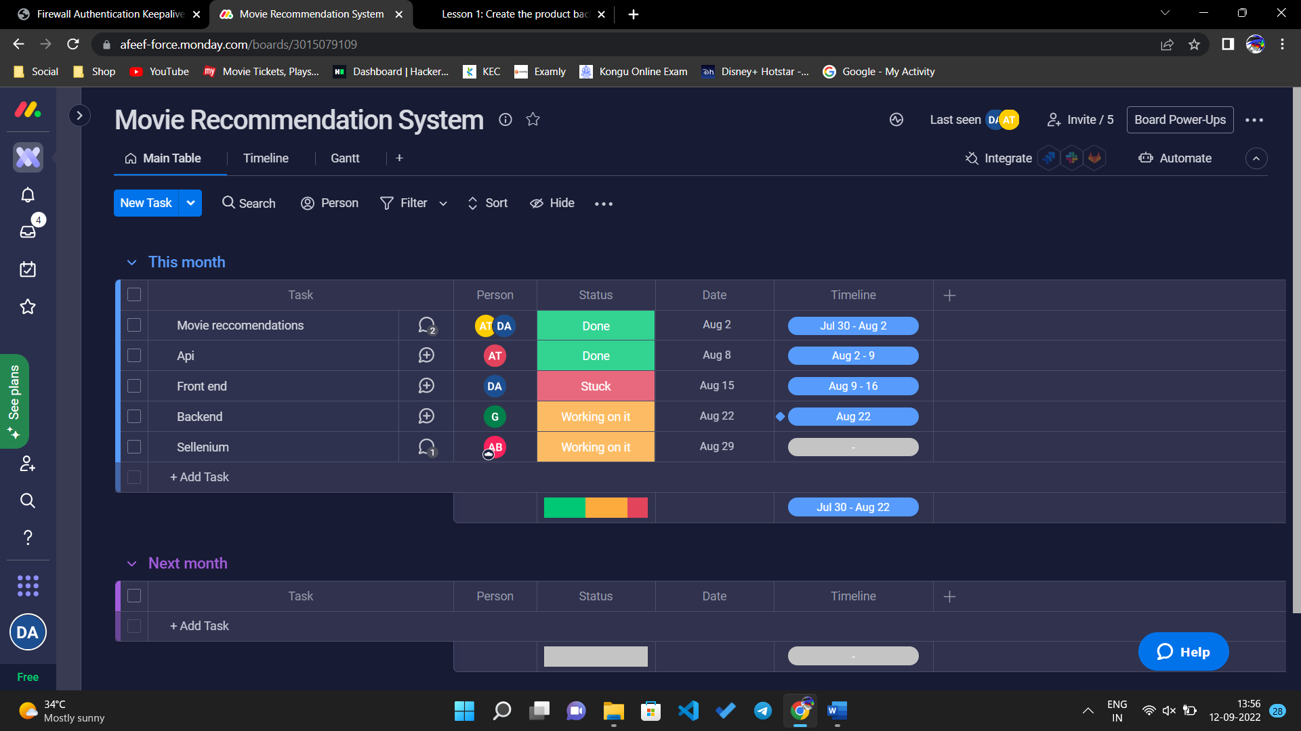

Move work items from the release backlog to sprint. In main, the work items can be drag from release to sprint.

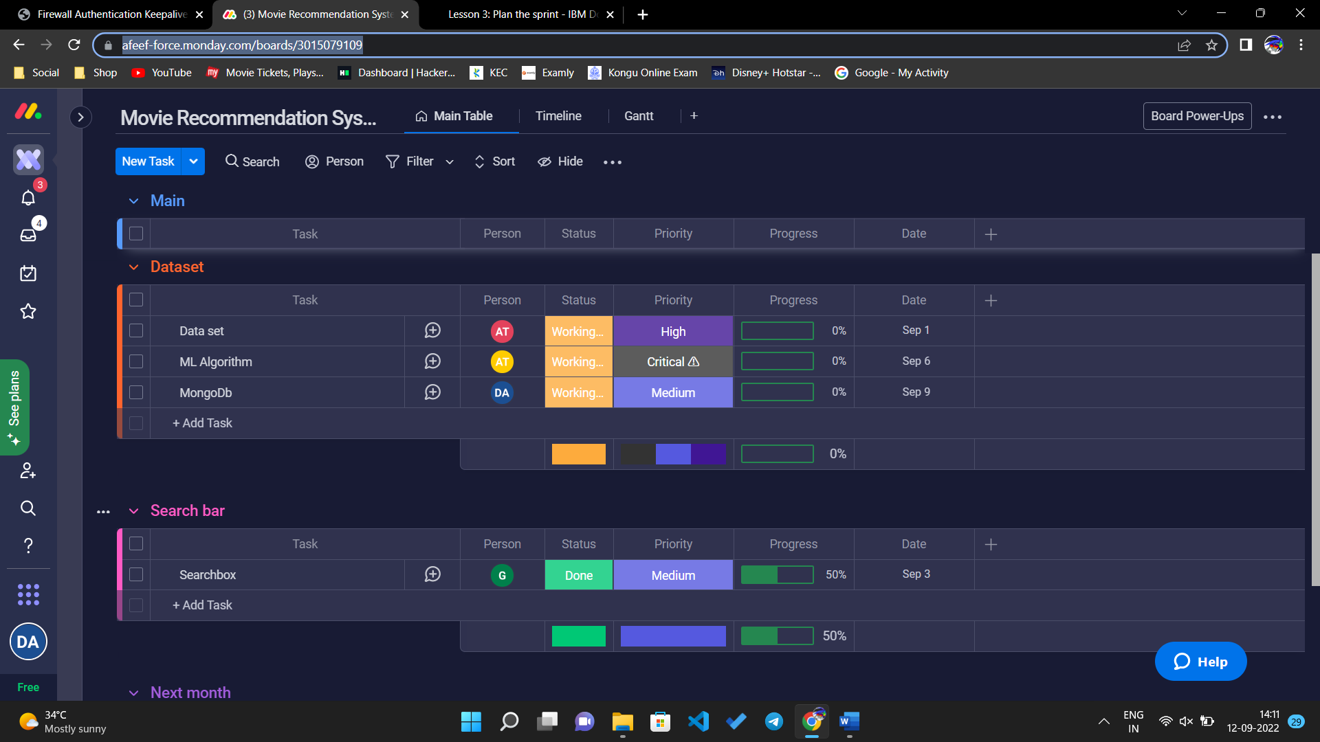

To complete the work for a story, add tasks that break the work into manageable chunks. In a typical sprint planning meeting, the team members mention the tasks to do and the scrum master records the tasks.

Estimate the tasks and assign their owners. The owners can be assigned by changing the person in the sprint.

Click the task to view subitems for a task and the time line for the subitems can also be used.

Continue to add estimates for all of the tasks in the story. After you finish estimating tasks, you can see the total estimates for the story and the entire sprint.

Monitor the available time for team members as they accept tasks by using the Planned Time view. In the row of each team member, a progress bar displays the work load report.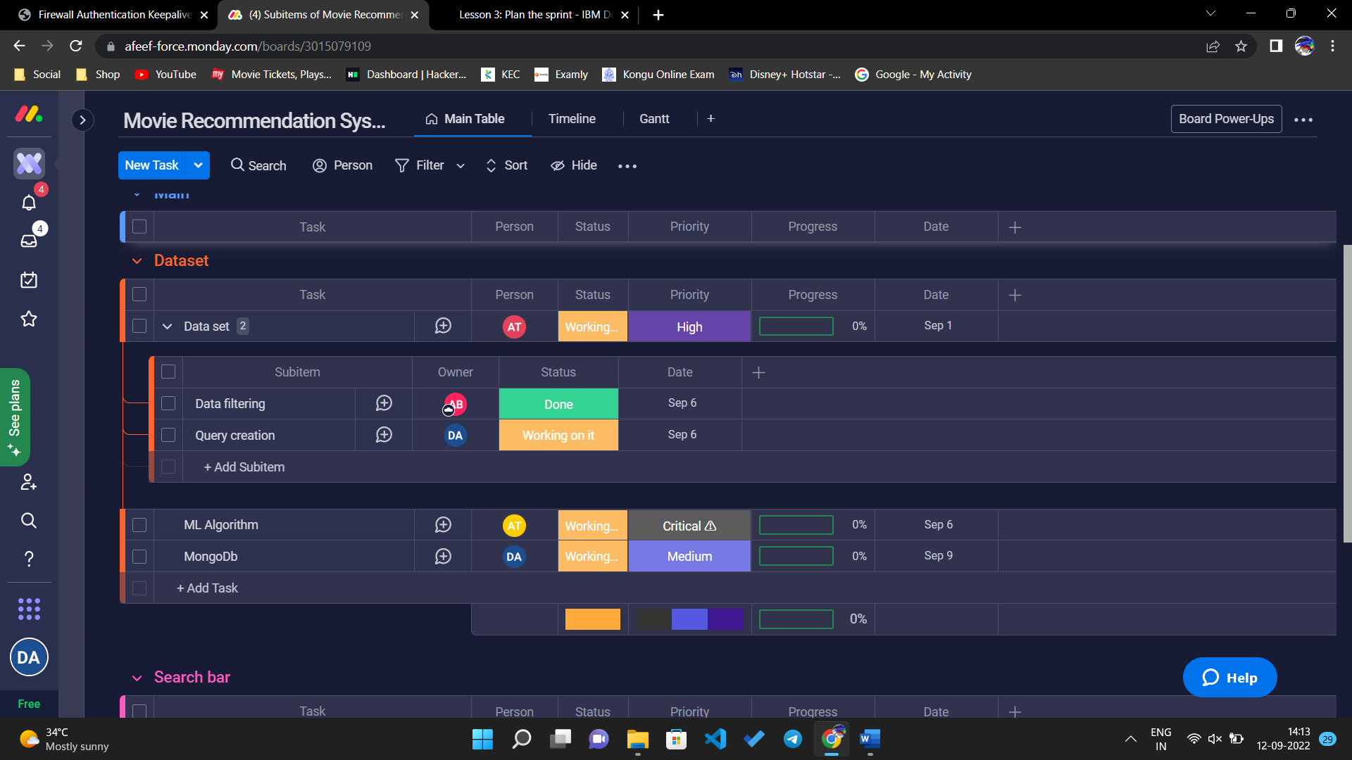

**CONCLUSION:**

Continue to estimate tasks until team members no longer have time available. For scrum teams to succeed, everyone's workload needs spare time to adjust for estimates that are inadequate or interruptions. All of the work that is committed must be completed, no matter what happens. Choose a percentage of spare time that fits your team.